Bon Air Country Club  2287 Club House Road  Glen Rock, PA 17327  717-235-2091  Fax 717-759-8358 | 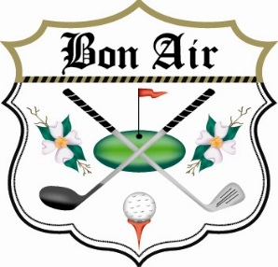

2017 “Golf for H.O.P.E.” Greens Flag Sponsorship
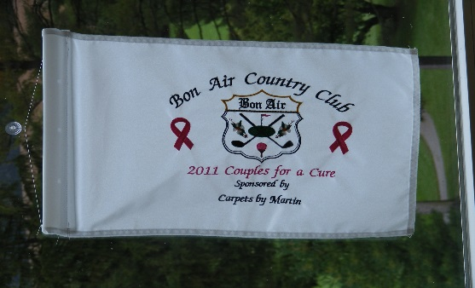
Join us in helping support All Cancer patients
and families as a Greens Flag Sponsor, for a
contribution of $100.00. Each flag is
customized with the sponsor’s name.

“Sponsored by”_____________________________________________________
(Name to be displayed on flag)

Contributing Sponsor:

Name: ______________________________________________________________________

Address: _____________________________________________________________________

City/State/Zip: ________________________________________________________________

Daytime #: __________________________________________________________________

Email: ____________________________________________________________________

Please make checks payable to Bon Air Country Club, with “Golf for H.O.P.E.” labeled on the check. H.O.P.E. is a 501 (C)(3) non-profit funded through donations which are tax deductible.

Flag orders must be received by September 15th. Contact the Pro Shop at 717-235-2091.

Thank you!

