Bon Air Country Club  2287 Club House Road  Glen Rock, PA 17327  717-235-2091  Fax 717-759-8358 | 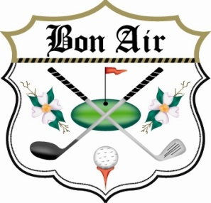

2017 “Golf for H.O.P.E.” Silent Auction and Prize Sponsor

Join us in helping support All Cancer patients and families as a Silent Auction or Team Prize Sponsor by donating items and/or gift cards.
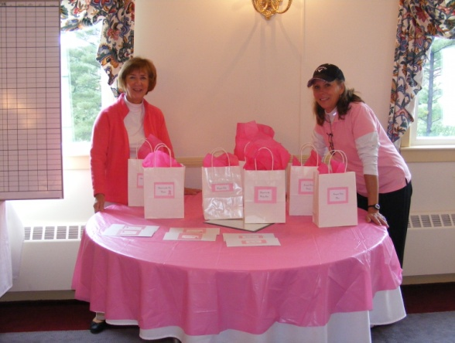
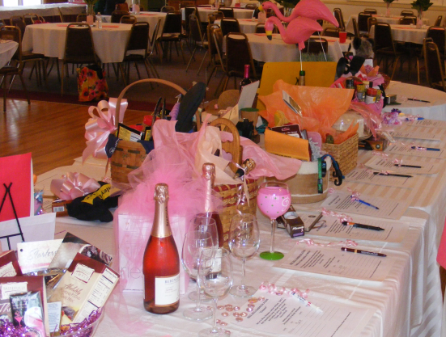

- Yes! I would like to be a Silent Auction Sponsor! Item(s) I will be contributing:
_____________________________________________________, valued at $________________.

- Yes! I would like to be a Team Prize Sponsor! Item(s) I will be contributing:
_____________________________________________________, valued at $________________.

Contributing Sponsor: ______________________________________________________
(Name, as you wish displayed in Gratitude brochure)

Contributing Sponsor information:

Name: ______________________________________________________________________________________________

Address: ______________________________________________________________________________________________

City/State/Zip: _________________________________________________________________________________________

Daytime #: ___________________________________________________________________________________________

Email: ____________________________________________________________________________________________

Please make checks payable to Bon Air Country Club, with “Golf for H.O.P.E.” labeled on the check. H.O.P.E. is a 501 (C)(3) non-profit funded through donations which are tax deductible.
Items will be received up to September 15th. Contact the Pro Shop at 717-235-2091.
Thank you!

