Bon Air Country Club  2287 Club House Road  Glen Rock, PA 17327  717-235-2091  Fax 717-759-8358 | 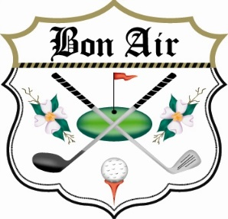

2017 “Golf for H.O.P.E.” Tee Box Sponsorship
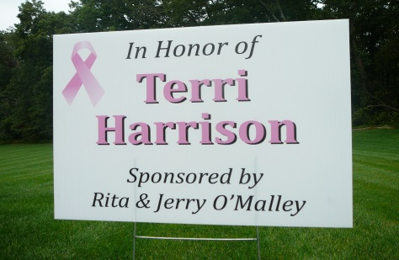
Join us in helping support All Cancer patients
and families as a Tee Box Sponsor, for a
Contribution of $40.00.

“In Honor of” _____________________________________________________
(Name to be displayed on sign)

“Sponsored by”_____________________________________________________
(Name to be displayed on sign)

“Cancer Ribbon color”______________________________________________
(Ribbon color to be displayed on sign)

_____________________________________________________________________________________

Contributing Sponsor:

Name: ______________________________________________________________________

Address: ______________________________________________________________________

City/State/Zip :_________________________________________________________________

Daytime #: __________________________________________________________________

Email: ____________________________________________________________________

Please make checks payable to Bon Air Country Club, with “Golf for H.O.P.E.” labeled on the check. H.O.P.E. is a 501 (C)(3) non-profit funded through donations which are tax deductible.

Sign orders must be received by September 15th. Contact the Pro Shop at 717-235-2091 if you have any questions. Thank you!

