2019 Bon Air Country Club
Tree Management Plan

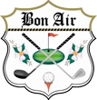

Prepared by:
Butch Howard – Superintendent
Billy Meredith – Greens & Grounds Chairman
Mark Scharf
Mike Bissett
Al Taylor

About
The Greens & Grounds committee of Bon Air Country Club present this tree management plan as a goal to work towards improving the playability, turf conditions, maintenance requirements, and aesthetics of the golf course.

Playability
Playability considers the fairness of the golf course regardless of the skill level, age, or gender of the player. When considering playability and tree management/removal the committee tried to take into consideration how a tree negatively impacts play, some examples of these negative impacts are, but not limited to, inability to have multiple ways to play a hole due to tree(s) forcing a particular shot, inability to make a swing within vicinity of fairway (<3 yds), and inability to hit ball on line towards green within vicinity of fairway (<3 yds).

Turf Conditions
Turf conditions consider how a tree affects the ground conditions in the immediate vicinity of the tree. Some examples of this are the ability to grow grass around a tree that is directly in the line of play and exposed root systems that become a problem for both golfers and maintenance equipment.

Maintenance Requirements
Maintenance requirements consider how the removal/maintenance of a tree will impact the maintenance staff’s ability to maintain the golf course. The primary factor here is determining whether the removal of a tree will decrease maintenance time on the course and, when also considering turf conditions, whether removal/maintenance of a tree lowers the amount of overhead required to complete a maintenance task on the course such as growing grass within an area of play.

Aesthetics
Aesthetics consider the look of the golf course and how trees on the course affect the look of the golf course and views of the surrounding land from the golf course. This is a very subjective criteria when considering trees for removal/maintenance though the committee feels strongly that Bon Air is built on a unique piece of land with more beautiful land surrounding the golf course and that the aesthetics of the course can be greatly improved with tree removal and/or maintenance.

Hole #2

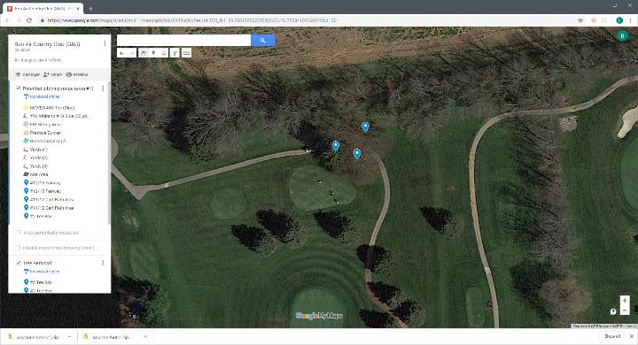
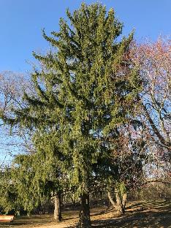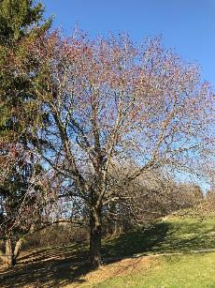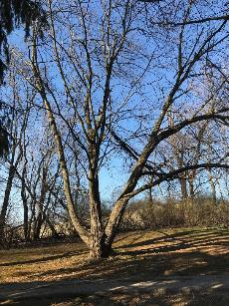
Info:
Norway Spruce and two Maples: These three trees negatively impact the maintenance staff’s ability to properly maintain a portion of #2 white/blue tee box. The root systems of these trees also negatively impact the adjacent cart path. Per the tee box plan, at a minimum the maple tree will need reduced to accommodate the newly placed blue tee box.

Hole #8

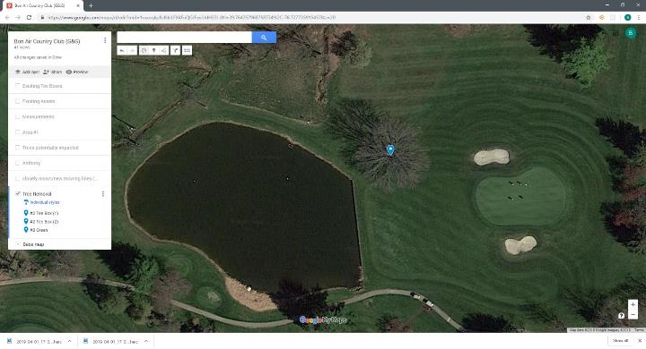
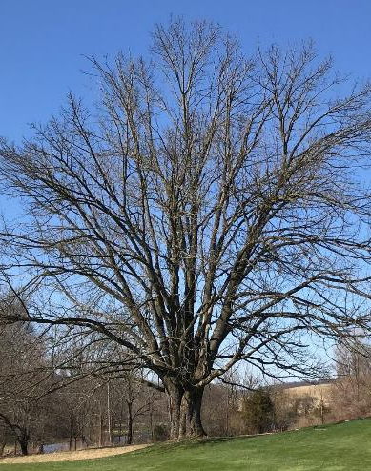
Info:
Ash tree is currently suffering Ash Decline and will likely contract EAB in near future according to Al Taylor. Al also notes that treatment for this tree from EAB is possible though expensive and would be required on a biennial basis. Tree is misplaced on golf course.

Hole #11

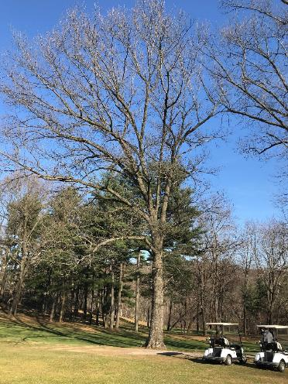
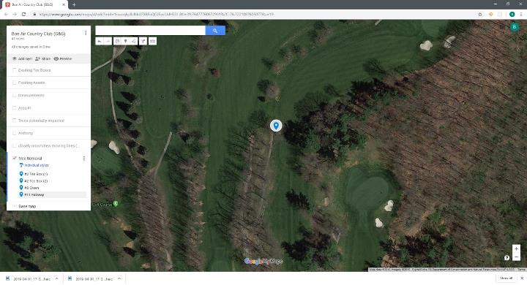
Info:
Per USGA this Oak tree is negatively impacting the ground conditions in the vicinity of tree which is directly in the field of play and therefore this tree should be removed. The root system of this tree also negatively impacts the adjacent cart paths on #11 and #12.
The “chute” from the tee box that players must navigate on this hole is also becoming very tight and, in the opinion of the committee, removal of this tree opens the chute and will positively impact play.

Hole #11/12

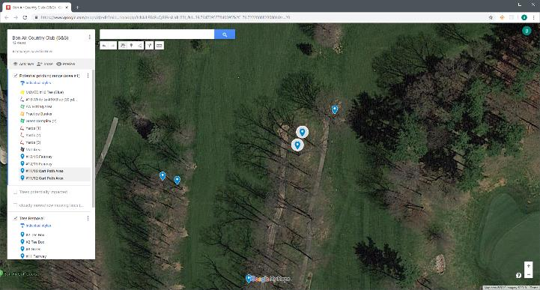
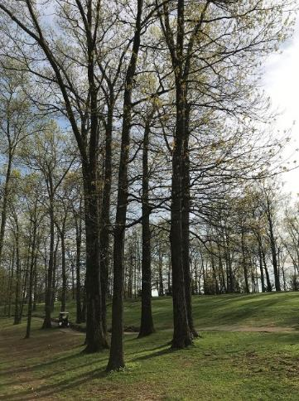
Info:
Per Al Taylor two oak trees in this area are both dead and present hazards from both a course and safety perspective.

Hole #12

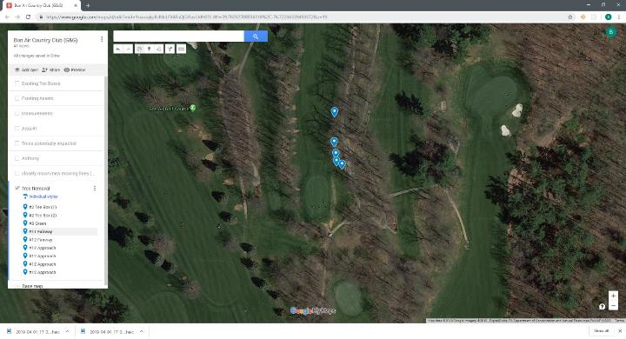
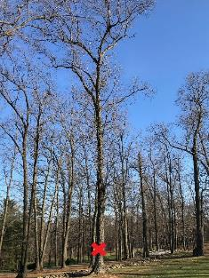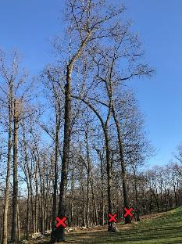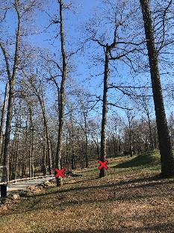
Info:
Per the USGA the six oak trees pictured and marked with a red X should be removed to improve playability of this hole and improve ground conditions in the left rough from 70 yards forward to the green complex.

Hole #12/15

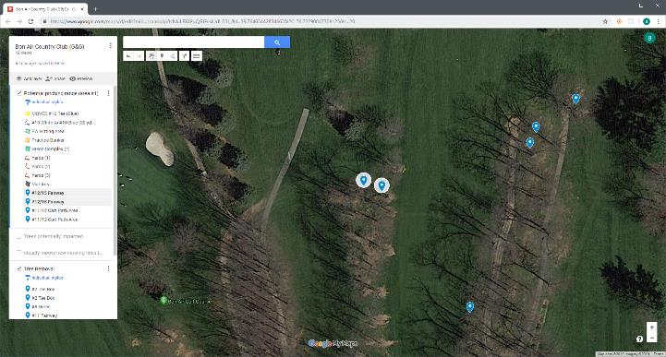
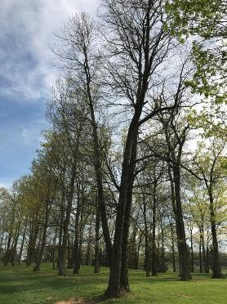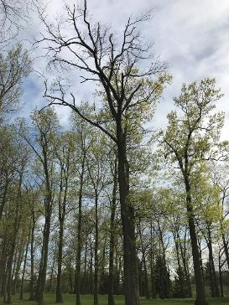
Info:
Per Al Taylor these two oak trees are both dead and present hazards from both a course and safety perspective.

Hole #15
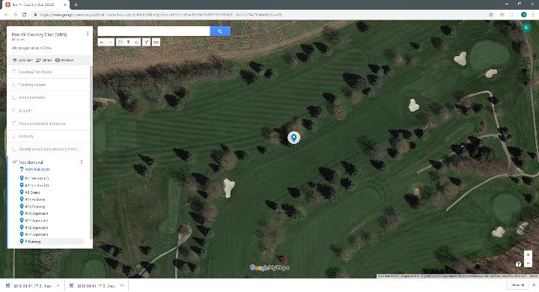
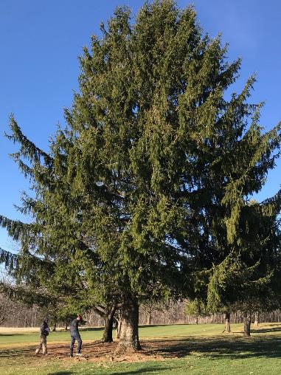
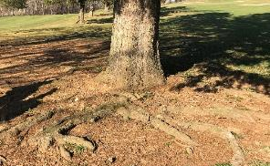
Info:
Norway Spruce has encroached directly into field of play. Shots from 2-3 yards into rough have no clear angle of approach when short of tree, when beside tree and 2-3 yards into rough swing is impeded by tree. There is an old distance marker near tree (in rough) showing that, due to this tree, the fairway has become roughly 5 yards narrower over time. Root system of tree has made entire ground area around tree unplayable. Due to size tree is currently misplaced on golf course.

Hole #18

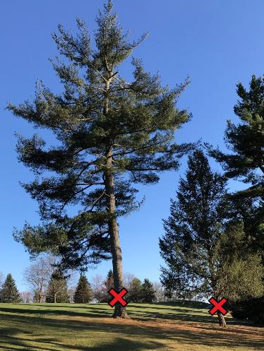
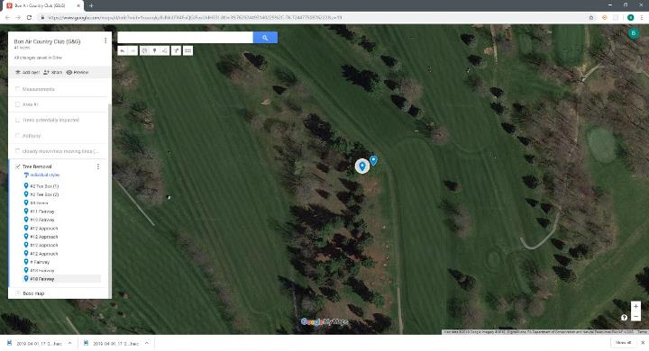
Info:
One White Pine and one Spruce tree in photo marked with red X negatively impact play by presenting no options for second shot on what is otherwise a great par 5. It is the opinion of the committee that second shots on a par 5 should present the most options of any shot on the golf course, between layups in certain spots and attempts at going for green.

